Jakarta BRT
Program Area: Developing High-Quality, Low-Cost Mass Transit
Country: Indonesia
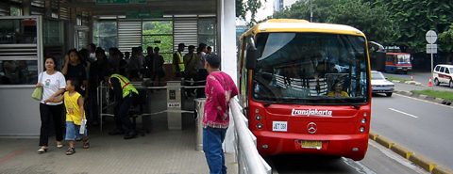
TransJakarta station (Source: Darmaningtyas, Instran)
Projected to be the fifth-largest city in the world by 2015, Jakarta, Indonesia has faced growing challenges in the traffic congestion and harmful pollution that result from the increasing use of cars and motorcycles.
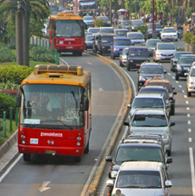The TransJakarta Bus Rapid Transit system was opened in December 2004 to provide a way for Jakarta’s citizens to get through the city’s notorious congestion and to reduce emissions. It represents a breakthrough for Asia as the region’s first full BRT system with physically separated bus-only lanes, at-level boarding platforms, pre-paid ticketing, and other features.
Implementing the TransJakarta system has been a high priority for Jakarta City Governor Sutiyoso’s administration and ITDP has been the leading source of international expertise for the project.
Photo by Michael Replogle, ITDP / Environmental Defense
Since its opening, TransJakarta has expanded to seven corridors and currently serves over 160,000 passengers a day. Travel time across the entire corridor has dropped by one hour during the peak period. Over 20% of TransJakarta passengers have switched from using private cars for some trips, and carbon dioxide emissions alone are being reduced at the rate of 20,000 metric tons a year.
Daily ridership is expected to reach 300,000 as the system expands to ten corridors by early 2008.
Based on the success of TransJakarta in reducing greenhouse gas emissions, the United Nations Environment Programme selected ITDP to work with the Government of Jakarta on strengthening the system further over the next five years. Enhancements will be made to the system’s design, operation, and fare collection, as well as improving the routing of non-BRT buses, pedestrian and bike facilities, and managing traffic demand with road pricing and other measures.
The project will rely on the continued involvement of key stakeholders, including ITDP’s non-governmental partners Instran and Yayasan Pelangi Indonesia.
For more information, please visit the project website at http://www.gobusway.org
Questions about this project can be directed to:
John Ernst
johnernst@itdp.org

